David Tom

CIT 180 Database Concepts & SQL

Assignment HW Final

December 10, 2023

**Database for Library Services**

The purpose of this database is to efficiently manage and track the operations of a local library system. It is vital to have a centralized system to handle book inventories, member information, loan records, and event management. The database will help in improving library services, making book borrowing easier, and organizing events effectively.

|  |
| --- |
| **TABLE OF CONTENTS** |

**Legal Notice............................................................................................................................1**

**Introduction............................................................................................................................2**

**Database Model......................................................................................................................2**

**Database Tables......................................................................................................................6**

* *Book Table.................................................................................................…………….6*
* *Member Table..........................................................................................….................6*
* *Loan Table...............................................................................................…….............7*
* *Event Table.............................................................................................……..............7*
* *Genre Table..........................................................................................…………….....7*
* *Staff Table………………………………………………………………………………..…...8*

**Application Architecture (Question 2)……………………………………………………9**

|  |
| --- |
| **LEGAL NOTICE** |

Copyright (c) 2023 of David Tom and Fictitious Database Services Inc. All rights reserved. This

file and the accompanying materials are made available as part of the CIT 180 Database Concepts and SQL course at CSN. <https://catalog.csn.edu/preview_course_nopop.php?catoid=3&coid=8175>.

|  |
| --- |
| **INTRODUCTION (Question 1: A)** |

The proposed Library Services database serves as the backbone for a comprehensive local library management system and has been designed to streamline and enhance the operational capabilities of the library. The database, while fictional in its composition, aims to closely mimic real life data pertaining to library operations. It plays a pivotal role in facilitating a range of services from book lending and returns to member management and event organization.

The database contains data that is intertwined for a more enriching querying experience and allows for users to query details of books, genres, and library events which have been based on real life library operations. Certain elements like member interactions and specific loan histories have been fictionalized to provide a more robust dataset for analysis and education.

|  |
| --- |
| **DATABASE MODEL (Question 1: B)** |

Expanding on the database model for the Library Services database, we will design it with six key tables: Book, Member, Loan, Event, Genre, and Staff. The structure and relationships between these tables are outlined below:

1. **Book Table**
   * Key Field: BookID (Primary Key)
   * Each book is associated with one genre (GenreID as a Foreign Key)
   * A book can be borrowed many times (related to multiple entries in the Loan table), but only by one member at any given time.
   * Fields: BookID (PK), Title, Author, ISBN, GenreID (FK), PubYear, Status, Description, ShelfLocation.
   * Connected to the Genre Table via GenreID (One-to-Many).
   * Connected to the Loan Table via BookID
2. **Member Table**
   * Key Field: MemberID (Primary Key)
   * Members can borrow multiple books (linked to many entries in the Loan table).
   * Members can register for multiple events (linked to many entries in the Event table through a Member-Event junction table).
   * Fields: MemberID (PK), Name, ContactInfo, StartDate, MembershipType.
   * Connected to the Loan Table via MemberID (One-to-Many).
   * Connected to the MemberEvent junction table via MemberID (One-to-Many).
3. **Loan Table**
   * Key Field: LoanID (Primary Key)
   * Each loan record is linked to one specific book (BookID as a foreign key) and one specific member (MemberID as a foreign key).
   * The Loan table tracks the history of each book borrowed, including dates and return status.
   * Fields: LoanID (PK), BookID (FK), MemberID (FK), LoanDate, DueDate, ReturnDate, LateFee.
   * Linked to both Book and Member Tables (Many-to-One.
4. **Event Table**
   * Key Field: EventID (Primary Key)
   * Each event is organized by one staff member (OrganizerID as a foreign key).
   * An event can have multiple registered members (managed through the Member-Event junction table).
   * Fields: EventID (PK), EventName, Description, OrganizerID (FK), EventDateTime, EventLocation, MaxParticipants.
   * Connected to the Staff Table via OrganizerID (Many-to-One).
   * Connected to the MemberEvent junction table via EventID (One-to-Many).
5. **Genre Table**
   * Key Field: GenreID (Primary Key)
   * Each genre can be associated with many books (linked to multiple entries in the Book table).
   * Fields: GenreID (PK), GenreName, Description.
   * Linked to the Book Table (One-to-Many).
6. **Staff Table**
   * Key Field: StaffID (Primary Key)
   * Each staff member can organized multiple events (linked to many entries in the Event table).
   * Staff members can have a hierarchical structure with supervisors (SupervisorID as a self-referencing foreign key).
   * Fields: StaffID (PK), Name, Role, ContactInfo, SupervisorID (FK).
   * Linked to the Event Table (One to Many).
7. **Junction Table: MemberEvent**
   * Key Field: MemberEventID (Primary Key)
   * The MemberEvent junction table manages the relationship between library members and the events they attend
   * The table resolves the many-to-many relationships where a single member can attend multiple events, and a single event can have multiple members attending.
   * Fields: MemberEventID (PK), MemberID (FK), EventID (FK), RegistrationDate, AttendanceStatus.
   * Connects the Member Table to the Event Table, facilitating the tracking of which members attend which events (Many-to-One).

|  |
| --- |
| **Question 1: C, E, J** |

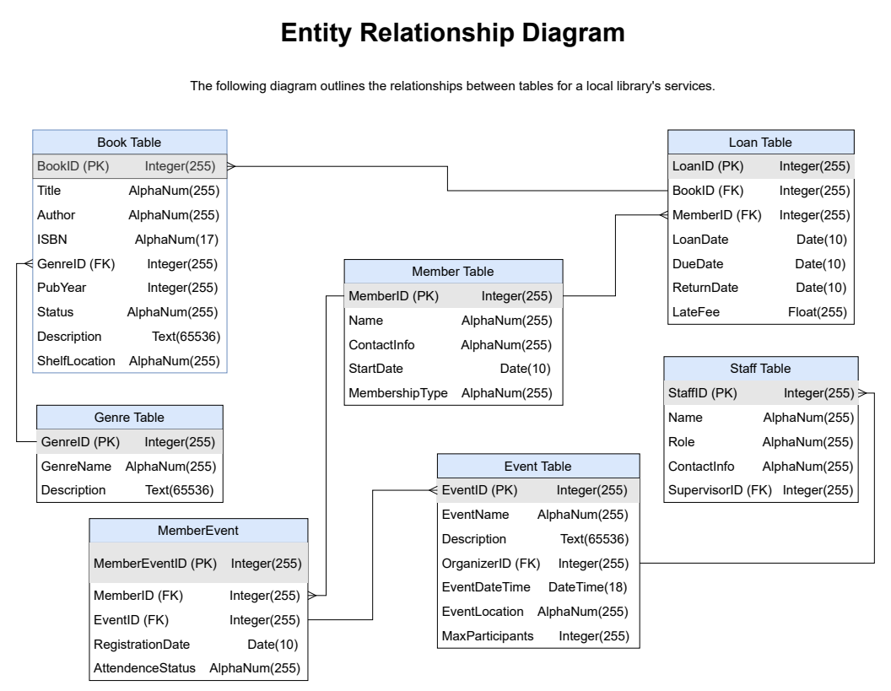

|  |
| --- |
| **DATABASE TABLES (Question 1: D)** |

**Book Table**

The Book Table contains detailed information about every book available in the library. The key to this table is ‘BookID’, a unique identifier for each book. The table includes the title of the book (‘Title’), the author’s name (‘Author’), and the International Standard Book Number (‘ISBN’). Each book is also linked to a genre through the ‘GenreID’, which is a foreign key connecting to the Genre Table.

Other important fields in the Book Table include the publication year (‘PubYear’), the book’s current status (ex. ‘Available’, ‘Borrowed’, ‘Reserved’), and a brief description (‘Description’). The table also records the physical location of the book within the library (‘ShelfLocation’).

The fictional table has grown to include over 50,000 books, encompassing a wide range of genres and topics. The data spans from classic literature to contemporary works with acquisition dates ranging from 1980 to the present day.

**Member Table**

The Member Table stores information about library members. The primary key is ‘MemberID’. It includes personal details such as the member’s name (‘Name’), contact information (‘ContactInfo’), and membership start date (‘StartDate’).

Each member is assigned a membership type (‘MembershipType’), which has been standardized to include fields such as ‘Students’, ‘Seniors’, ‘Children’, ‘Young Adults’, and ‘Adults’, influencing borrowing privileges. The table also tracks the member’s borrowing history though a relationship with the Loan Table.

The Member Table holds records of around 10,000 active members, tracking their library interactions from the start of the digital record system in 2005.

**Loan Table**

The Loan Table tracks the borrowing details of library books by members. It is key with ‘LoanID’, an auto-generated unique identifier for each loan transaction. The table records the ‘BookID’ and ‘MemberID’ (both Foreign Keys), the date when the book was borrowed (‘LoanDate’), and the due date for return (‘DueDate’).

The Loan Table also includes the actual return date (‘ReturnDate’), which is crucial for managing overdue books and calculating any late fees (‘LateFee’). The table provides invaluable insights into borrowing trends and book popularity.

The Loan Table has a substantial record of approximately 200,000 loan transactions, detailing the borrowing activities from 2005 onwards.

**Event Table**

The Event Table manages the various events organized by the library. The key field is ‘EventID’. Each event has a name (‘EventName’), a detailed description (‘Description’), and the date and time it’s scheduled (‘EventDatetime’).

The ‘OrganizerID’ field, a foreign key, links to the Staff Table, indicating which staff member is responsible for the event. The table also includes information on the event location within the library (‘EventLocation’) and the maximum number of participants (‘MaxParticipants’).

The Event Table manages a diverse array of library events, with around 1,500 events recorded since 2010.

**Genre Table**

The Genre Table categorizes books into different genres. Its primary key is ‘GenreID’. The table includes the genre name (‘GenreName’) and a description (‘Description’). The table allows for easy classification and retrieval of books, aiding in member recommendations and library organization.

The Genre Table contains approximately 30 distinct genres.

**Staff Table**

The Staff Table contains details about the library’s staff, including those involved in event organization and general management. The key field is ‘StaffID’. It includes the staff member’s name (‘Name’), role or designation (‘Role’), contact details (‘ContactInfo’), and the ID of their supervisor (‘SupervisorID’), which is a self-referencing foreign key. The table is essential for managing staff responsibilities and streamlining library operations.

The Staff table compromises details of around 100 staff members, including librarians, event organizers, and administrative personnel, with records dating back to 2000.

|  |
| --- |
| **APPLICATION ARCHITECTURE (Question 2)** |

The chosen architecture for the given system is dependent on several factors such as scalability, performance, security, and maintenance needs. Based on the information available in the Library Services database a three-tier architecture has been selected to facilitate the needs of the system. The architecture aligns with modern application development and deployment practices and offers a balanced approach to managing the various aspect of the Library Services database system.

**Reason for Decision**

As the library grows, the architecture can accommodate increased loads by scaling each tier independently (Scaling). By seperating the database from the client layer, sensitive data is better protected against unauthorized access (Security). Each layer can be updated or maintained independently, reducing downtime and simplifying updates (Maintainability). Different technologies can be used for each tier, allowing for the best tools to be used for each aspect of the application (Flexibility). Distributing the workload across three tiers can lead to more efficient processing and a better user experience (Performance).

**The Three-Tier Architecture Description**

1. Presentation Layer (Client Tier):
   * The Presentation Layer is where the users interact with the sytem. It can be a web interface or a desktop program that librarians and library members use to access and manage data (ex. Borrowing books, registering for events, etc.). The seperation from the Business Logic Layer improves user experience and makes the applications easier to update or modify.
2. Business Logic Layer (Application Server Tier):
   * The middle tier processes user requests, executes business logic and rules, and communicate with the database. It acts as an intermediary between the presentation layer and the database. The fact that the layer is not directly exposed to the client also increases security and allows for more efficient data processing as it can allow multiple requests simultaneously.
3. Data Layer (Database Tier):
   * The Data Layer is where the Library Services database resides. It is stored and manages all the data related to books, members, loans, events, etc. The centralization of data storage improves data integrity and management. It also facilitates backups, recovery, and data access controls.